 4th Annual Ocean County

March Madness Tournament

Saturday March 11th, at 10 A.M Check in at 9 A.M.

Finnegan’s Lanes 101 Locust St, Lakewood, NJ 08701

**Entry fee: $65 if paid in full by 12/31/2022**, $75 as of 1/1/2023**

*Walk-in allowed if space permits (cash only for walk-ins)*

Zelle accepted: **OCUSBCA@Gmail.com**

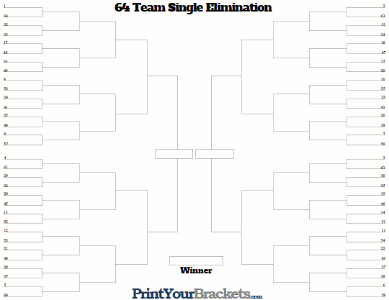



Name:_________________________________ USBC#: ___________________ Avg: ___________

Address:__________________________________________________________________________

City/State/Zip: _____________________________________________________________________

Phone #:_______________________ Email:_____________________________________

***For additional information, contact George Williams at:*** [***TheAngelCharlie@gmail.com***](mailto:TheAngelCharlie@gmail.com)

***Or*** [***OCUSBCA@gmail.com***](mailto:OCUSBCA@gmail.com)

** Reduced Entry fee ($65) is available from 12/01/2022-12/31/2022. MUST BE PAID IN FULL**

As of 1/1/2023 entry fee is $75.

Once spot is paid in full the bowler/entrant will be able to pick their starting lane assignment. First come, first served (see rule #8 for process to select lane assignment)

Unlimited handicap and scratch brackets and pots.

**Rules:**

1.The previous tournament was sold out. Prepayments of tournament will take precedence over walk-ins. Full payment required to secure guarantee spot.

2. All USBC rules will prevail throughout this tournament

3. 128 Max entries, 4 per lane

4. $65 reduced entry if paid in full by 12/31/2022- $75 entry fee as of 1/1/2023. $75 Walk-in (cash only if space permits) Minimum of 75% towards prize fund.

5. Handicap is 80% of 220 (use highest **winter average**, based on **42** games from the past two years (2021-2022 and 2020-2021). *Summer averages are not accepted.* If you do not have 42 games to qualify, bowlers must use an average of 220. No give back over 220.

6. Open to all USBC Sanctioned bowlers.

7. Four games across four pairs skipping one pair to the right, cut to top 64 (one game roll-off if there is a tie).

* Top 64 will go into a 64-man bracket. 1 bowls 64, 2 bowls 63, etc.
* If the number of entries is between 32-64, the top 32 bowlers will be taken. Top four bowlers will be considered #1 seeds. 64-man bracket will also use handicap.
* Ties in the 64-man bracket will go to a 9th and 10th frame roll off. Higher seed starts first. No handicap on roll offs.
* Sweet 16 (16 bowlers left) and better will cash. Payouts will be within 60 minutes of the end of the tournament.
* Four #1 seeds receive bonus cash.

8. Starting lane selection for full payment. Once bowler/ entrant has made full payment they will be contacted (email / Phone/ Facebook/ or in person) for desired starting lane. If not, available they will be able to choose from the remaining spots. First come, First served.

Lanes 1-2 and 35-36 are out of play (break down pairs)

Moving of lanes will be skip one pair to right after each game, with the house being broken into 2 sections (lanes 3-18 and 19-34) ***Example Lanes 17-18 will move to Lanes 5-6 and Lanes 33-34 will move to Lanes 21-22***

*Premature termination of this Tournament brought about by war, national emergency, or emergency causes related thereto and there from - Fire, strikes, lockouts, labor difficulties or other reasons beyond the control of the Ocean County USBC Association, shall cause the forgoing prize schedule to be pro-rated in accordance with the number of entrants who have bowled in each of the respective events up to the time of termination. Automatic scoring keeping systems are used. Tournament Management has the discretionary authority to determine if any irretrievable game and/or frame (s) should be re-bowled (USBC Rule 327c). Likewise, any equipment malfunctions (USBC Rule 321) resulting in delays and/or rescheduling will be the decision of the Tournament Management (USBC Rule 303). Tournament Management reserves all rights to make interpretations of these rules as necessary (USBC Rule 303).*

***Visit our website for additional information*** [***OCUSBCA.org***](http://WWW.OCUSBCA.org)